

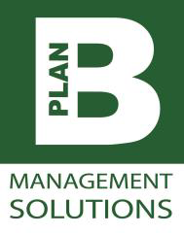

“"It was dirty work but very rewarding, I managed four units in a day not bad for a beginner apparently! A unit arrive from Brentwood Recycling Centre and I saw it go through the whole process as it was prepared for sale and collection".
Shaun Eldridge
Materials Lead, HWRC

Thinking Responsibly, Acting Sustainably
The Lighthouse Project
Case Study
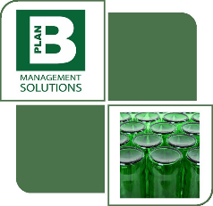
The Charity

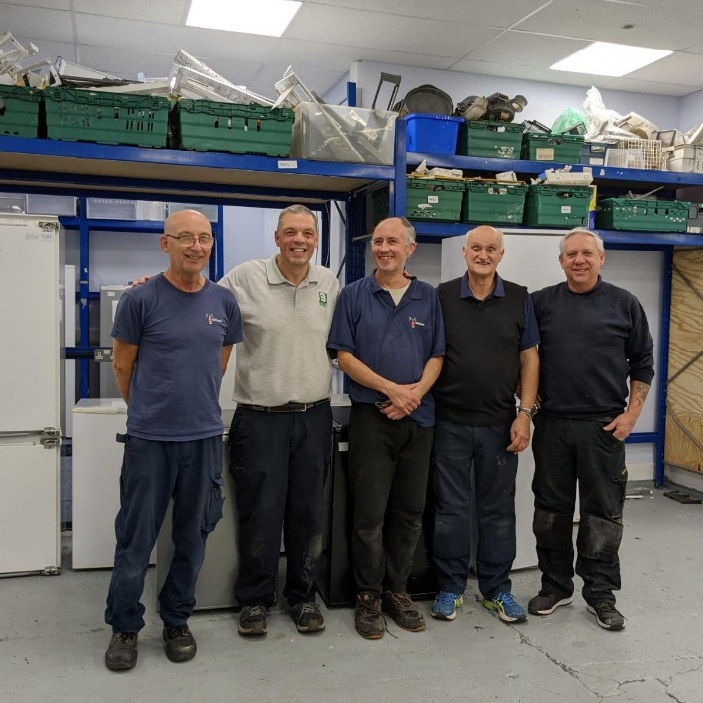
LFP are Plan B's chosen Charity partner to work with on our Essex County Council HWRC Materials Recycling and Treatment contract. LFP is a charity that takes pre-loved items, and renovates them to be reused by those in the area who need some support when setting up home. They provide furniture, beds, electrical items etc at a reduced cost via the emergency living fund.
Shaun's job on the day was to muck in and help Steve, one of the cleaners to prepare Large Domestic Appliances for purchase and collection by clients. This included washing, cleaning and repairing shelves or pipes in the appliances.

The Solution

Head Office: Gilmarde House, 47 South Bar Street, Banbury OX16 9AB
mail@pbmsolutions.co.uk Tel: 01242 806330 www.pbmsolutions.co.uk

